Installation of SonarQube:

1. Pre-requisites for SonarQube are:

a) System should have minimum 4 GB of RAM. So I am taking T2.Medium

b) Java 8 should be installed

c) One Database should be installed

1. I am taking one Ubuntu (t2.medium) and installing java 8. For installation of java in Ubuntu you can visit the below link

<https://tecadmin.net/install-oracle-java-8-ubuntu-via-ppa/>

Or

https://www.youtube.com/watch?v=JQxIFr4zRRs

1. sudo apt-get install unzip –y
2. wget <https://sonarsource.bintray.com/Distribution/sonarqube/sonarqube-5.6.6.zip>
3. unzip sonarqube-5.6.6.zip
4. cd sonarcube-5.6.6/

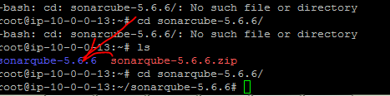

1. Now install mysql server

apt-get install mysql-server –y

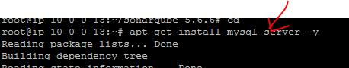

1. It will prompt for password you can keep any password but I am keeping password as

123456

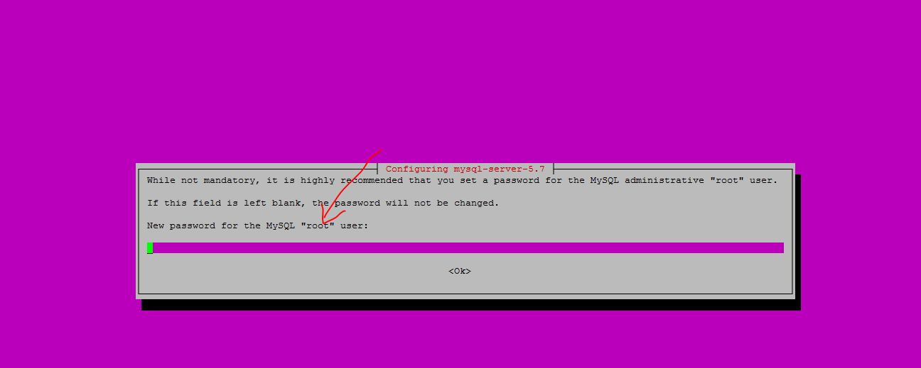

Again it will ask to reenter the password

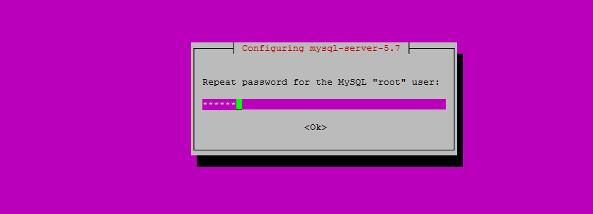

1. Now connect to mysql database

Username is root

Password is 123456

Now type mysql –u root –p (press enter,it will ask for password enter the password)

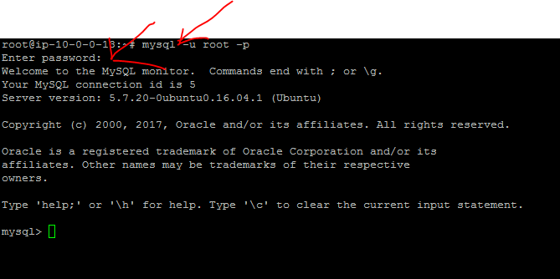

1. In sql prompt please enter the following and press enter

CREATE DATABASE sonar CHARACTER SET utf8 COLLATE utf8_general_ci;

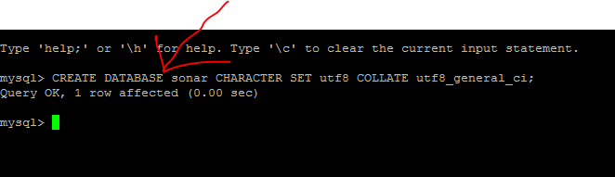

1. In sql prompt now type the following and press enter

CREATE USER 'sonar' IDENTIFIED BY 'sonar';

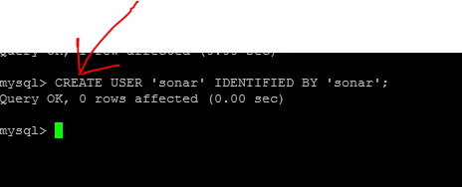

1. Now in sql type and press enter

GRANT ALL ON sonar.* TO 'sonar'@'%' IDENTIFIED BY 'sonar';

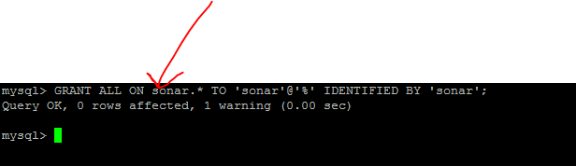

1. Now in sql type and press enter

GRANT ALL ON sonar.* TO 'sonar'@'localhost' IDENTIFIED BY 'sonar';

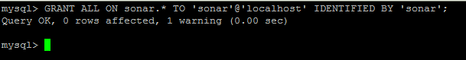

1. Now in sql type and press enter

FLUSH PRIVILEGES;

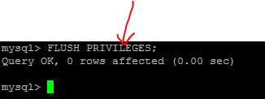

1. Now come out of mysql by typing exit
2. Now in root directory we downloaded sonarzip file,move to that folder.

Inside that folder move to conf directory

There will be a file by name sonar.properties

Open sonar.properties file by using vi

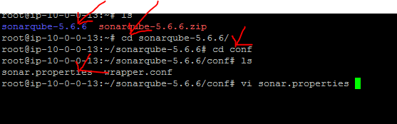

1. Uncomment sonardb username ,sonardb password and one url as mentioned below

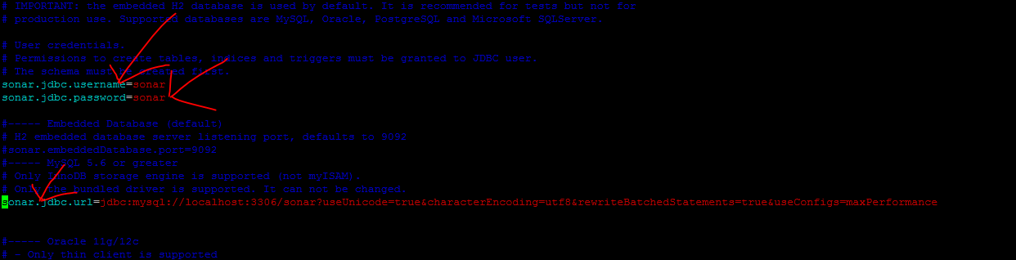

Save and exit

1. Now go to bin directory of sonarcube ,

inside bin move to linux-x86-64

inside linux-x86-64 there is a file by name sonar.sh

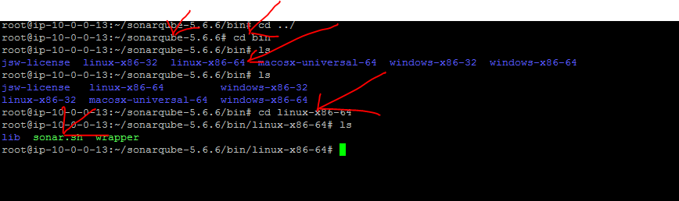

1. Now start the sonar service by typing sh sonar.sh start

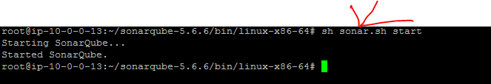

1. Stop the fire walls by typing service ufw stop

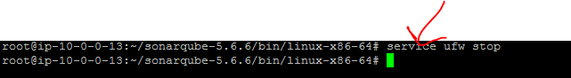

1. Now in security group please open the ports 9000,3306

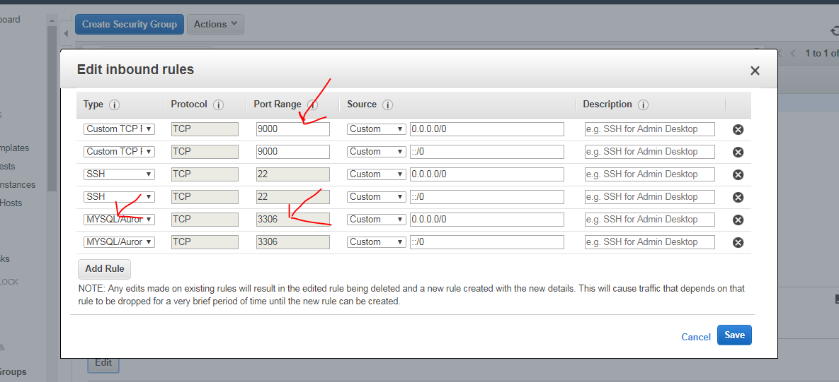

Take the public ip of sonarqube and paste it in browser like this .

In my case **13.126.129.189:9000**

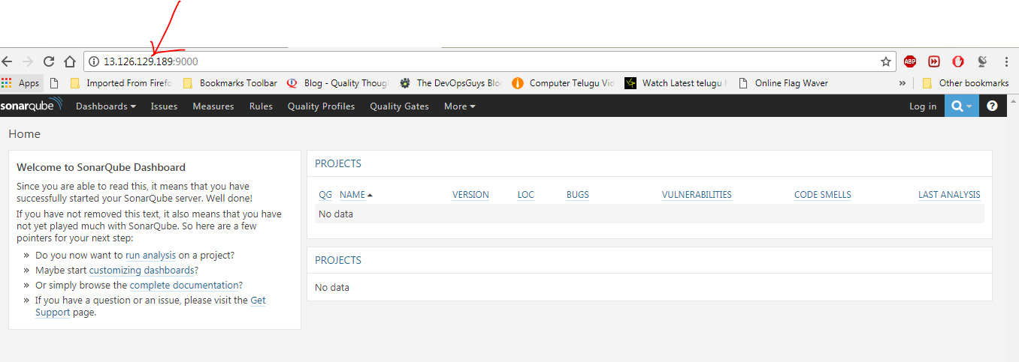

1. You can log in into sonarqube

Default username is 🡪admin

Password is🡪 admin

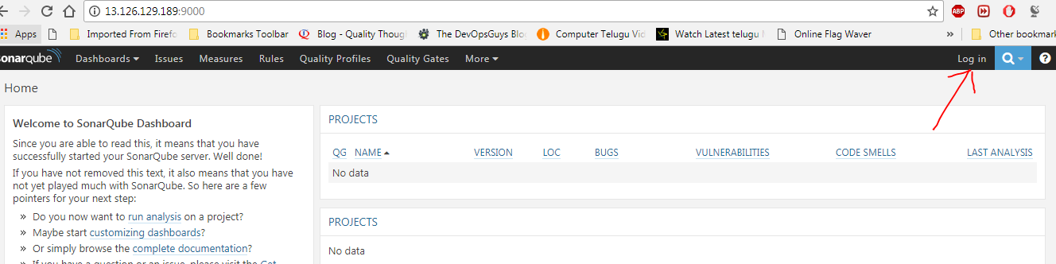

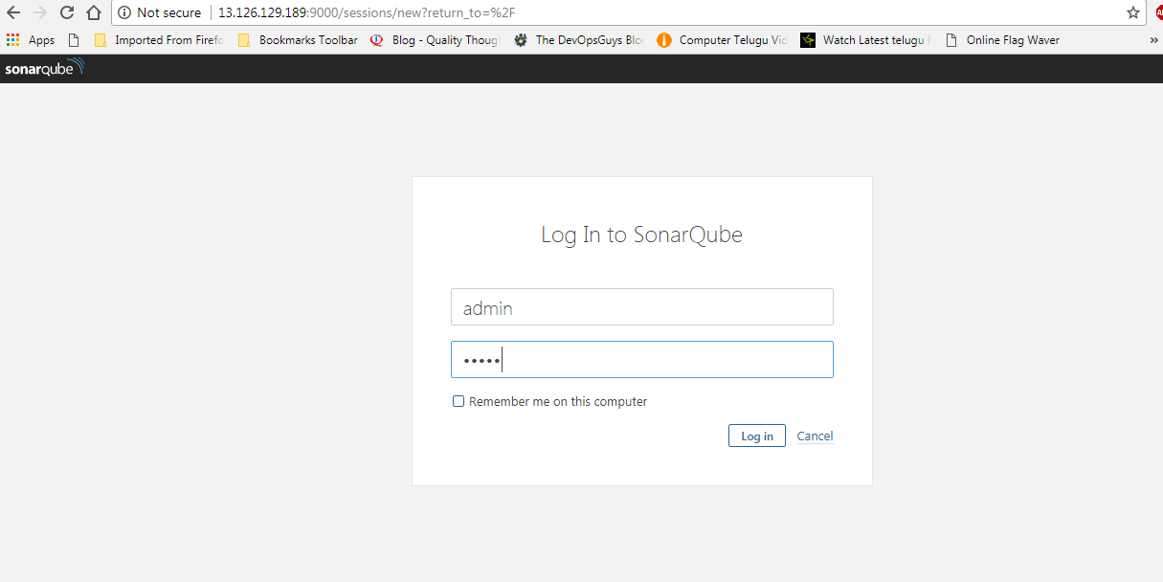

This is the installation of SonarQube in Ubuntu